Description: Description: G:\2017-18\SCHOOL ALL OVER\BODHI LOGO.jpg**VELAMMAL BODHI CAMPUS**

**GRADE: X - IIT GRAND TEST-1 SUB: SCIENCE (086) DATE: 10.01.2024 MARKS: 80 (3 HOURS)**

**General Instructions:**

i. This question paper consists of 39 questions in 5 sections.

ii. All questions are compulsory. However, an internal choice is provided in some questions. A student is expected to attempt only one of these questions.

iii. Section A consists of 20 objective type questions carrying 1 mark each.

iv. Section B consists of 6 Very Short questions carrying 02 marks each. Answers to these questions should in the range of 30 to 50 words.

v. Section C consists of 7 Short Answer type questions carrying 03 marks each. Answers to these questions should in the range of 50 to 80 words

vi. Section D consists of 3 Long Answer type questions carrying 05 marks each. Answer to these questions should be in the range of 80 to 120 words.

vii. Section E consists of 3 source-based/case-based units of assessment of 04 marks each with sub-parts.

**Section-A**

**(Select and write the most appropriate option out of the four options given for each of the questions 1 - 20. Each question carries 1 mark.)**

1.

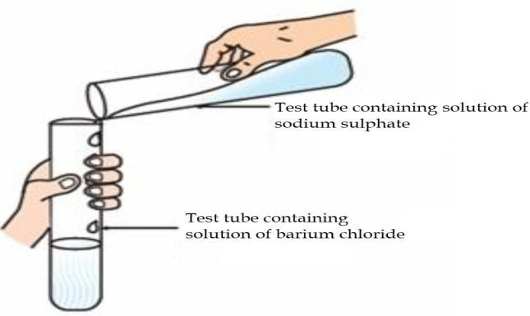

Identify the product which represents the solid state in the above reaction.

1. Barium chloride (b) Barium sulphate

(c) Sodium chloride (d) Sodium sulphate

2. The colour of the solution observed after 30 minutes of placing zinc metal to copper sulphate solution is

(a) Blue (b) Colourless (c) Dirty green (d) Reddish Brown

3. Mild non-corrosive basic salt is

(a) Ca (OH)2 (b) NaCl (c) NaOH (d) NaHCO3

4. On adding dilute sulphuric acid to a test tube containing a metal ‘X’, a

colourless gas is produced when a burning match stick is brought near it.

Which of the following correctly represents metal ‘X’?

(a) Sodium (b) Sulphur (c) Copper (d) Silver

5. Which of the following is not a physical change

a) Boiling of water to give a water vapour b) Melting of ice to give water

c) Dissolution of salt in water d) Combustion of LPG.

6. The most ductile metal is

a) Gold b) Silver c) Aluminum d) Copper

7. The pH of soil is 5.5. In order to increase the pH. A farmer would have to

add which of the following to the soil.

(a) Potassium hydroxide (b) Slaked lime

(c)Gypsum (d) Sodium hydroxide

8. Generally food is broken and absorbed within the body of organisms.

In which of the following organisms is it done outside the body?

(a) *Amoeba* (b) Mushroom(c)Paramoecium(d) Lice

9. Receptors are usually located in sense organs. Gustatory receptors are

present in

(a) tongue (b) nose (c) eye (d) ear

10. A farmer wants to grow banana plants genetically similar enough to the

plants already available in his field. Which one of the following methods

would you suggest for this purpose?

1. Regeneration (b) Budding

(c) Vegetative propagation (d) Sexual reproduction

11. Height of a plant is regulated by:

(a) DNA which is directly influenced by growth hormone.

(b) Genes which regulate the proteins directly.

(c) Growth hormones under the influence of the enzymes coded by a gene.

(d) Growth hormones directly under the influence a gene.

12. A sportsman, after a long break of his routine exercise, suffered

muscular cramps during a heavy exercise session. This happened due to:

1. lack of carbon dioxide and formation of pyruvate.
2. presence of oxygen and formation of ethanol.
3. lack of oxygen and formation of lactic acid.

(d) lack of oxygen and formation of carbon dioxide.

13. An object is placed in front of a convex mirror. Its image is formed:

(a) at a distance equal to the object distance in front of the mirror.

(b) at twice the distance of the object in front of the mirror.

(c) half the distance of the object in front of the mirror.

(d) behind the mirror and it’s position varies according to the object distance.

14. When light enters the atmosphere it strikes on extremely fine particles,

which deflect the rays of light in all possible directions, This is due to -

1. reflection of light (b) atmospheric refraction

(c) scattering of light (d) dispersion of light

15. In 1987, an agreement was formulated by the United Nations

Environment Programme (UNEP) to freeze the production of “X” to prevent

depletion of “Y”. “X” and “Y” respectively referred here are:

1. Ozone; CFCs (b) CFCs; rays UV
2. (c) CFCs; Ozone (d) UV rays; Diatomic oxygen

16. Which of the following features relates to biodegradable substances?

(a) Broken down by biological processes (b) Remain inert

(c) Persist in environment for long time (d) May harm the ecosystem

**Question No. 17 to 20 consist of two statements – Assertion (A) and Reason (R). Answer these questions selecting the appropriate option given below:**

1. Both A and R are true, and R is the correct explanation of A.
2. Both A and R are true, and R is not the correct explanation of A.
3. A is true but R is false.
4. A is false but R is true.

17. **Assertion:** Rusting of Iron is endothermic in nature.

**Reason**: As the reaction is slow, the release of heat is barely evident.

18. **Assertion:** The progeny in F2-generation traits were identical to their

parental type.

**Reason:** The progeny show no blending of traits.

19. **Assertion**: A compass needle is placed near a current carrying wire. The

deflection of the compass needle decreases when the magnitude

of the current in the wire is increased.

**Reason**: The strength of a magnetic field at a point near the

conductor increases on increasing the current.

20**. Assertion**: Biodegradable substances result in the formation of compost

and natural replenishment.

**Reason**: It is due to breakdown of complex inorganic substances into

simple organic substances.

**Section-B**

**(Question No. 21 to 26 are very short answer questions. Each question carries 2 mark.)**

21. Dil. HCl is added to Zn granules.” How will you prove that chemical change has taken place here? Support your response with two arguments.

22. State the post-fertilisation changes that lead to fruit formation in plants.

23. What is the purpose of making urine in the human body? Name the organs that stores and releases the urine.

**OR**

List three characteristics of lungs which make it an efficient respiratory surface.

24. The refractive indices of three media are given below:

|  |  |
| --- | --- |
| **Medium** | **Refractive Index** |
| A | 1.6 |
| B | 1.8 |
| C | 1.5 |

A ray of light is travelling from A to B and another ray is travelling from

B to C.

1. In which of the two cases the refracted ray bends towards the normal?
2. In which case does the speed of light increase in the second medium? Give reasons for your answer.

25. A piece of wire of resistance R is cut into three equal parts. These parts

are then connected in parallel. If the equivalent resistance of this

parallel combination is R1, what is the value of the ratio R1 : R?

**OR**

Refer to the image below and state how the magnetic field pattern indicates regions where the magnetic field is stronger outside the magnet? What happens to the magnetic field when the current in the circuit is reversed?

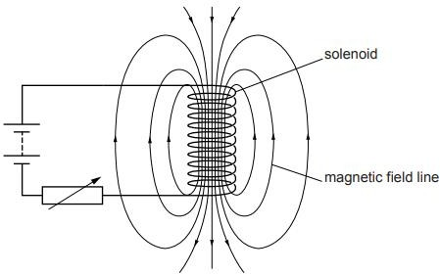

26.Study the food chain given below and answer the questions that follow:

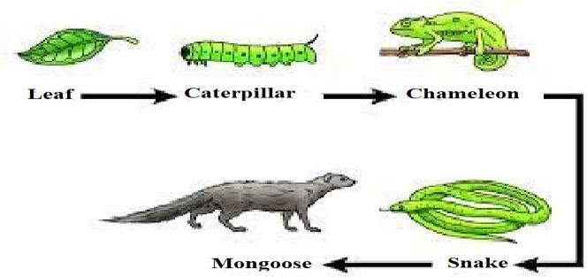

(a) If the amount of energy available at the third trophic level is 100 joules, then how much energy will be available at the producer level? Justify your answer.

(b) Is it possible to have 2 more trophic levels in this food chain just before the fourth trophic level? Justify your answer.

**Section-C**

**(Question No. 27 to 33 are short answer questions. Each question carries 3 mark.)**

27. The given reaction shows one of the processes to extract the metals like Iron and Manganese.

MnO₂ (s) + Al(s) → Mn(l) + Al₂O₃(s) + Heat

1. Give reason why the above reaction is known as a thermite reaction.
2. Identify the substance oxidised and reduced in the above reaction.
3. Give a reason why Aluminium is preferably used in thermite reactions.

28. Define the terms i) Minerals ii) Ore iii) Gangue

***OR***

A reddish-brown metal ‘X’, when heated in air, gives a black compound ‘Y’, which when heated in presence of H₂ gas gives ‘X’ back. ‘X’ is refined by the process of electrolysis; this refined form of ‘X’ is used in electrical wiring. Identify ‘X’ and ‘Y’. Draw a well-labeled diagram to represent the process of refining ‘X’.

29. (i) “The breathing cycle is rhythmic whereas exchange of gases is a

continuous process”. Justify this statement.

(ii) How do guard cells regulate the opening and closing of stomatal pore?

30. In the **F2** generation of a cross, progeny having different traits are

produced in the ratio 3 : 1. State whether it is a monohybrid cross or a

dihybrid cross ? Give one example of such a cross.

31. (i) Explain why the refractive index of any material with respect to air is

always greater 1.

(ii) In the figure below a light ray travels from air into the semi-circular

plastic block. Give a reason why the ray does not deviate at the

semi-circular boundary of the plastic block.

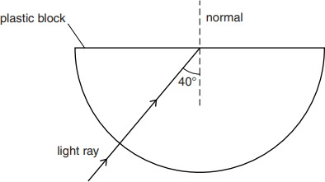

(iii) Complete the ray diagram of the above scenario when the light ray

comes out of the plastic block from the top flat end.

32. (i) State the law that explains the heating effect of current with respect

to the measurable properties in an electrical circuit.

(ii) List the factors on which the resistance of a conductor depends.

33. Anannya responded to the question: Why do electrical appliances with

metallic bodies are connected to the mains through a three pin plug,

where as an electric bulb can be connected with a two pin plug?

She wrote: Three pin connections reduce heating of connecting wires.

1. Is her answer correct or incorrect? Justify.
2. What is the function of a fuse in a domestic circuit?

**Section-D**

**(Question No. 34 to 36 are long answer questions. Each question carries 5 mark.)**

34. (a) Rehmat classified the reaction between Methane and Chlorine in presence of sunlight as a substitution reaction. Support Rehmat’s view with suitable justification and illustrate the reaction with the help of a balanced chemical equation.

(b) Chlorine gas was prepared using electrolysis of brine solution. Write the chemical equation to represent the change. Identify the other products formed in the process and give one application of each.

**OR**

Raina while doing certain reactions observed that heating of substance ‘X’ with vinegar like smell with a substance ‘Y’ (which is used as an industrial solvent) in presence of conc. Sulphuric acid on a water bath gives a sweet-smelling liquid ‘Z’ having molecular formula C4H8O2. When heated with caustic soda (NaOH), ‘Z’ gives back the sodium salt of and the compound ‘Y’. Identify ‘X’, ‘Y’, and ‘Z’. Illustrate the changes with the help of suitable chemical equations.

35. Given below are certain situations. Analyze and describe its possible impact on a person:

1. Testes of a male boy are not able to descend into scrotum during his embryonic development.
2. Vas deferens of a man is plugged.
3. Prostate and seminal vesicles are not functional.
4. Egg is not fertilised in a human female.
5. Placenta does not attach to the uterus optimally.

**OR**

(a) A doctor has advised Sameer to reduce sugar intake in his diet and do regular exercise after checking his blood test reports. Which disease do you think Sameer is suffering from? Name the hormone responsible for this disease and the organ producing the hormone. Which hormone is present in the areas of rapid cell division in a plant and which hormone inhibits the growth?

36.

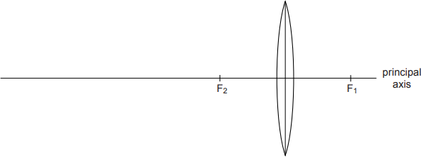

The above image shows a thin lens of focal length 5m.

1. What is the kind of lens shown in the above figure?
2. If a real inverted image is to be formed by this lens at a distance of 7m from the optical centre, then show with calculation where should the object be placed?
3. Draw a neatly labelled diagram of the image formation mentioned in the above question (ii)

**OR**

A 10 cm long pencil is placed 5 cm in front of a concave mirror having a radius of curvature of 40 cm.

1. Determine the position of the image formed by this mirror.
2. What is the size of the image?
3. Draw a ray diagram to show the formation of the image as mentioned in the part (i).

**Section-E**

**(Question No. 37 to 39 are case-based/data -based questions with 2 to 3 short sub-parts. Internal choice is provided in one of these sub-parts. Each question carries 4 mark.)**

37. The table given below shows the hints given by the quiz master in a quiz.

|  |  |
| --- | --- |
| **S.NO** | **HINT** |
| (i) | Substance ‘C’ is used as a preservative. |
| (ii) | ‘C’ has two carbon atoms; ‘C’ is obtained by the reaction of ‘A’ in presence of alkaline Potassium permanganate followed by acidification. |
| (iii) | Misuse of ‘A’ in industries is prevented by adding Methanol, Benzene, and pyridine to ‘A’. |
| (iv) | ‘F’ is formed on heating ‘A’ in presence of conc. Sulphuric acid. |
| (v) | ‘F’ reacts with Hydrogen gas in presence of Nickel and Palladium catalyst |

Based on the above hints answer the following questions

1. Give the IUPAC names of A and F
2. Illustrate with the help of chemical equations the changes taking place.

(A ⇒ C and A⇒ F)

**OR**

Name the chemical reactions which occur in steps 2 and 5. Identify the

Compounds formed in these steps if ‘A’ is replaced with its next

homologue.

**38.** Figures (a) to (d) given below represent the type of ear lobes present in a familyconsisting of 2 children – Rahul, Nisha and their parents.

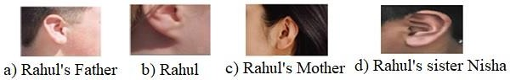

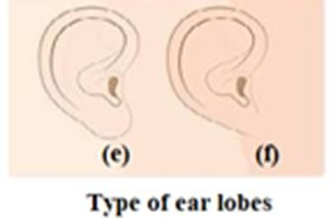

Excited by his observation of different types of ear lobes present in his family, Rahul conducted a survey of the type of ear lobes found {Figure (e) and (f)} in his classmates. He found two types of ear lobes in his classmates as per the frequency given below:

|  |  |  |
| --- | --- | --- |
| **Sex** | **Free** | **Attached** |
| Male | 36 | 14 |
| Female | 31 | 19 |

On the basis of above data answer the following questions.

1. What are traits?
2. Which of the two characteristics - ‘free ear lobe’ or ‘attached ear lobe’ appears to be dominant in this case? Why?
3. Is the inheritance of the free ear lobe linked with sex of the individual? Give reason for your answer.
4. What type of ear lobe is present in father, mother, Rahul and his sister Nisha? Write the genetic constitution of each of these family members which explains the inheritance of this character in this family?

(Gene for Free ear lobe is represented by F and gene for attached ear lobe is represented by f for writing the genetic constitution).

39.

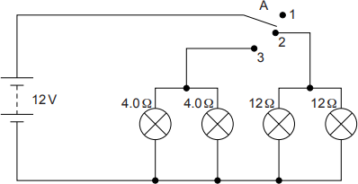

Vinita and Ahmed demonstrated a circuit that operates the two headlights and the two sidelights of a car, in their school exhibition. Based on their demonstrated circuit, answer the following questions.

1. State what happens when switch A is connected to

a) Position 2

b) Position 3

1. Find the potential difference across each lamp when lit.
2. Calculate the current

a) In each 12 Ω lamp when lit.

b) In each 4 Ω lamp when lit.

**OR**

1. Show, with calculations, which type of lamp, 4.0 Ω or 12 Ω, has the higher power.